Session 03 DML OperationsTrainer Coverage:Insert, Update, Delete records.WHERE and LIMIT usage.Example: Insert 5 sample users and edit their data.Pending

Q:-01 Create a SQL table called Restaurants with columns: id (INT, auto-increment), name (VARCHAR), cuisine (VARCHAR), rating (DECIMAL), and city (VARCHAR). Insert 5 sample restaurants into the table, each with a different cuisine and rating.

Create Table Query:-
create table restaurants(
id integer primary key auto_increment,
name varchar(100),
cuisine varchar(100),
rating real,
city varchar(50));
Insert Query:-INSERT INTO restaurants(name, cuisine, rating, city) VALUES
('La Pinoz', 'Pizza', 4.4, 'Rajkot'),
('Gordhan Thal', 'Gujarati', 4.5, 'Ahmedabad'),
('Subway', 'Fast Food', 4.1, 'Rajkot'),
('The Eatery', 'North Indian', 4.3, 'Ahmedabad'),
('Rasotsav', 'Gujarati', 4.6, 'Rajkot');

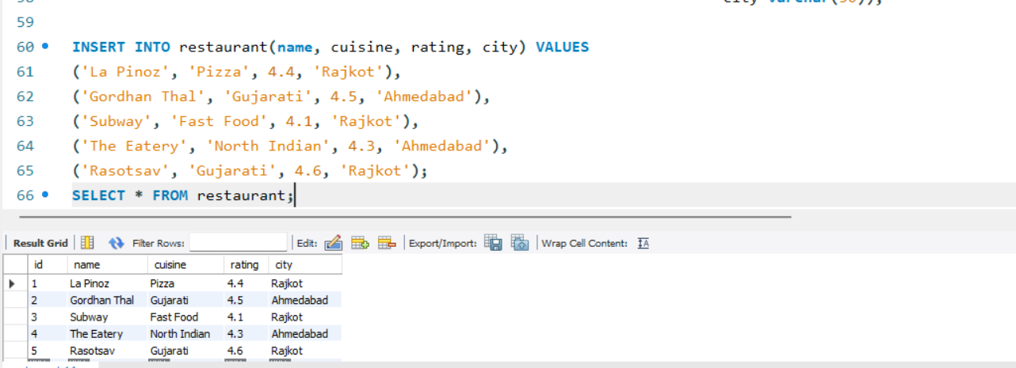

Q-02 Write a SQL UPDATE statement to change the rating of the restaurant named 'Spice Villa' to 4.7 in the Restaurants table.
update restaurants set name = 'Spice Villa' ,rating = 4.7 where id =2;

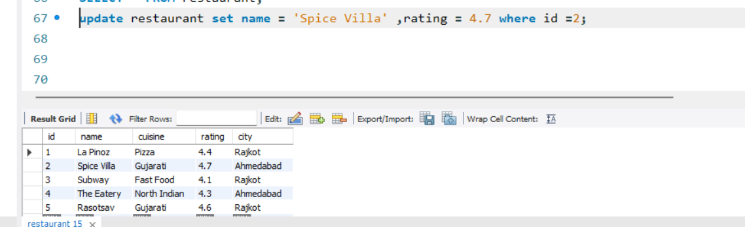
Q-03 Delete all restaurants from the Restaurants table where the rating is less than 3.5 using a SQL DELETE statement.

delete from restaurants where rating < 3.5;

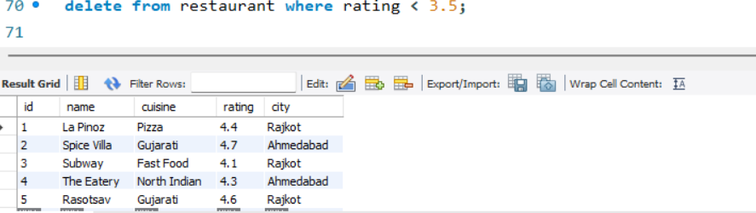

Q-04 Use a SELECT query with WHERE and LIMIT to fetch the top 2 restaurants in the city 'Ahmedabad' with a rating above 4.0 from the Restaurants table.Combine WHERE for city and rating, and LIMIT to restrict the number of results.

select * from restaurants where city = 'Ahmedabad'
AND rating > 4.0 LIMIT 2;

